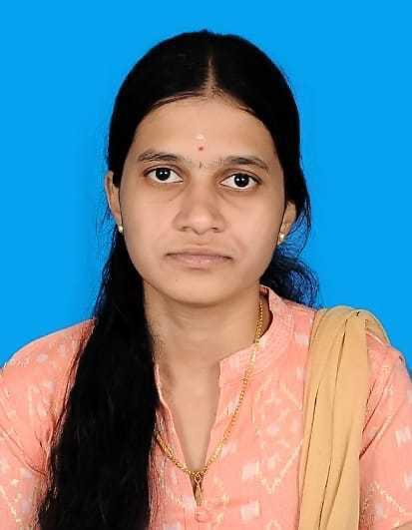
PRIYANKA R
priyankaiirt@gmail.com | 8778015851

PROFESSIONAL SUMMARY

Proficient Full Stack Developer familiar with a broad spectrum of programming utilities and languages. Effortlessly handles all aspects of the development process. Collaborative team member with strong technical abilities, providing around 3 + years of valuable experience.

EXPERIENCE

PROVILITY SOFTWARE SOLUTIONS - CHENNAI, TAMIL NADU October 2021 - Present
Software Engineer

• Proficient in developing robust and scalable web applications utilizing a combination of frontend (JavaScript, TypeScript, RxJS, Redux) and backend (Java, Spring Boot, Spring ,Groovy,.Net) technologies.
• Familiarity with Angular and Ionic framework for rapid application development.
• Hands-on experience with project management tools such as Jira, GitHub, and Bitbucket for collaborative development and issue tracking.
• Proficient in using integrated development environments like IntelliJ IDEA and Visual Studio for efficient coding and debugging workflows.

ACADEMICS

Degree/ Certificate | Board/University | School/college | Year of passing | Percentage (%)
B.Tech Information Technology | Anna University | Institute of Road and Transport Technology-Erode | 2020 | 77.1
12 | State Board | SRV Girls Higher  Secondary School- Namakkal | 2016 | 85.3
10 | State Board | SRV Girls Higher  Secondary School- Namakkal | 2014 | 94.4

SKILLS

● Frontend : JavaScript, Typescript, RxJS , Redux, HTML, CSS, Bootstrap,kendo.
● Backend : Java, Spring Boot, Spring, Groovy,ASP .Net Core.
● Database : MySQL, Postgres, Neo4J,Azure.
● Framework : Angular, Ionic
● Libraries : NgRX, Angular-Formly, React, Formik.
● Project Management Tools : Jira, Github, Bitbucket.
● Integrated development Environment : IntelliJ Idea, Visual Studio.

PROJECTS

1.ROBOGEBRA

OCT 2024 – PRESENT

Summary:
- RoboGebra is a versatile learning application tailored for students, focusing initially on mathematics. It features two main sections: a Backoffice for admin functionalities and a User App that lets students scan books, select topics, take quizzes, and receive step-by-step solutions for math problems. The app supports personalized learning timelines, study reminders, and a study list to keep students organized and engaged.

Contributions:
- Created a dynamic home page that displays personalized learning timelineprogress and access recent activity.
- Built a remainder page where students can set study reminders and receive notifications
- Added functionality for creating, updating, and organizing a study list, allowing students to set goals and manage tasks.
- Integrated a quiz module that allows students to test their knowledge and view step-by-step solutions for better understanding.
- Developed robust REST APIs for remainder management, including GET, POST, PUT, and DELETE operations for managing study reminders and tasks.Wroted a test cases in the backend
- Implemented comprehensive error handling and form validation on both frontend and backend to enhance security and data integrity.
- Designed and implemented a responsive mobile UI using Ionic to ensure a smooth experience across mobile devices.

Technology:

● Angular,Ionic,Java,Mysql

2.SUBSEA

APRIL 2024 – SEP 2024

Summary:

- The Subsea Project is a specialized software solution designed to manageand optimize subsea operations,including tools,pipeline connections,and quipments related to ships and marineactivities.The project focuses on efficiently handlingcategories.subcategories,andvarious types of equipment,streamlines processes for improved productivity and operational management.

Contributions:

- Fixed production functionality bugs, ensuring smooth operation and reliability.
- Implemented a new module called Schedule-Manager for managing subsea schedules.
- Developed APIs for the Schedule-Manager module using .NET, enabling seamless backend integration.
- Utilized Kendo UI Grid to implement complex UI functionality, enhancing user experience and data management.
- Designed and developed dynamic category and subcategory management features, allowing for flexible configuration of subsea equipment and tools.
- Assisted in refining the overall architecture, focusing on modularity and reusability to support futureexpansions.
Technology:

● Angular, .NET, Docker, Azure Database

3.BACKOFFICE UI ANGULAR VERSION MIGARTION

FEB 2024–MAR 2024

Summary:

• The Backoffice UI underwent a migration to the latest Angular version, aiming to modernize and improve performance. Meticulous testing ensured a seamless transition while minimizing disruptions to existing features. This upgrade not only aligned the UI with current Angular advancements but also set the stage for future enhancements and scalability.

Contributions:

• Migrated four repositories to version 16.

• Migrated the Ticketing web application from version 2 to 16.

• Migrated the ssg web plugin app repository from version 9 to 16.

• Migrated the ssg web plugin app gopass repository from version 4 to 16.

• Migrated the ssg web plugin app version admin repository from version 4 to 16.

4.EASYVISA

Nov 2021 – JAN 2024

Summary:

• The Visa Management System is a comprehensive software application designed specifically for attorneys to efficiently manage their clients, records, forms, and organizational visa processes. This project streamlines the visa application and documentation process, providing attorneys with a centralized platform to effectively handle their caseload and enhance their productivity.

Contributions:

• Implemented the full document portal module, featuring multiple accordion panels for uploading documents.
• Developed custom components using Angular Formly.

• Utilized Angular reactive forms extensively to construct nested forms.

• Customized the image cropper library for profile image usage.

• Migrated to a newer version of Angular, resulting in improved performance and stability.

• Created reusable components employed across multiple modules.

• Wrote unit test cases for all UI components and services.

• Assisted in documenting software specifications and user manuals.

Technology:

● Angular, Grails, Groovy, Postgres, Neo4

Date:

Place
Name & Signature

